
.
SIXTH SUNDAY IN ORDINARY TIME  FEBRUARY 11, 2018


Sat. Feb. 10 VIGIL-SIXTH SUNDAY IN ORDINARY TIME
4:00pm Ida Arredondo by Family

Sun. Feb. 11 SIXTH SUNDAY IN ORDINARY TIME
8:30am Vincent Chiodo by Arlene Perrotti
9:45am For the People of the Parish

Mon. Feb. 12 WEEKDAY SIXTH WEEK IN ORDINARY TIME
8:30am Communion Service & Novena of the Miraculous Medal

Wed. Feb. 14 ASH WEDNESDAY
8:30am Anna Marcinek by Daryl & Kathleen Schultz
7:00pm Prayer Service and Distribution of Ashes

Thurs. Feb. 15 NO COMMUNION SERVICE

Sat. Feb. 17 VIGIL-FIRST SUNDAY OF LENT
4:00pm For the People of the Parish

Sun. Feb. 18 FIRST SUNDAY OF LENT
8:30am Trudy Phillips by Jim & Eileen Kohn
9:45am Health of Riley Canas by Kathy Fossetta

The Sanctuary Candles burn this week
in memory of Vinnie Chiodo
by Mary Ann Chiodo

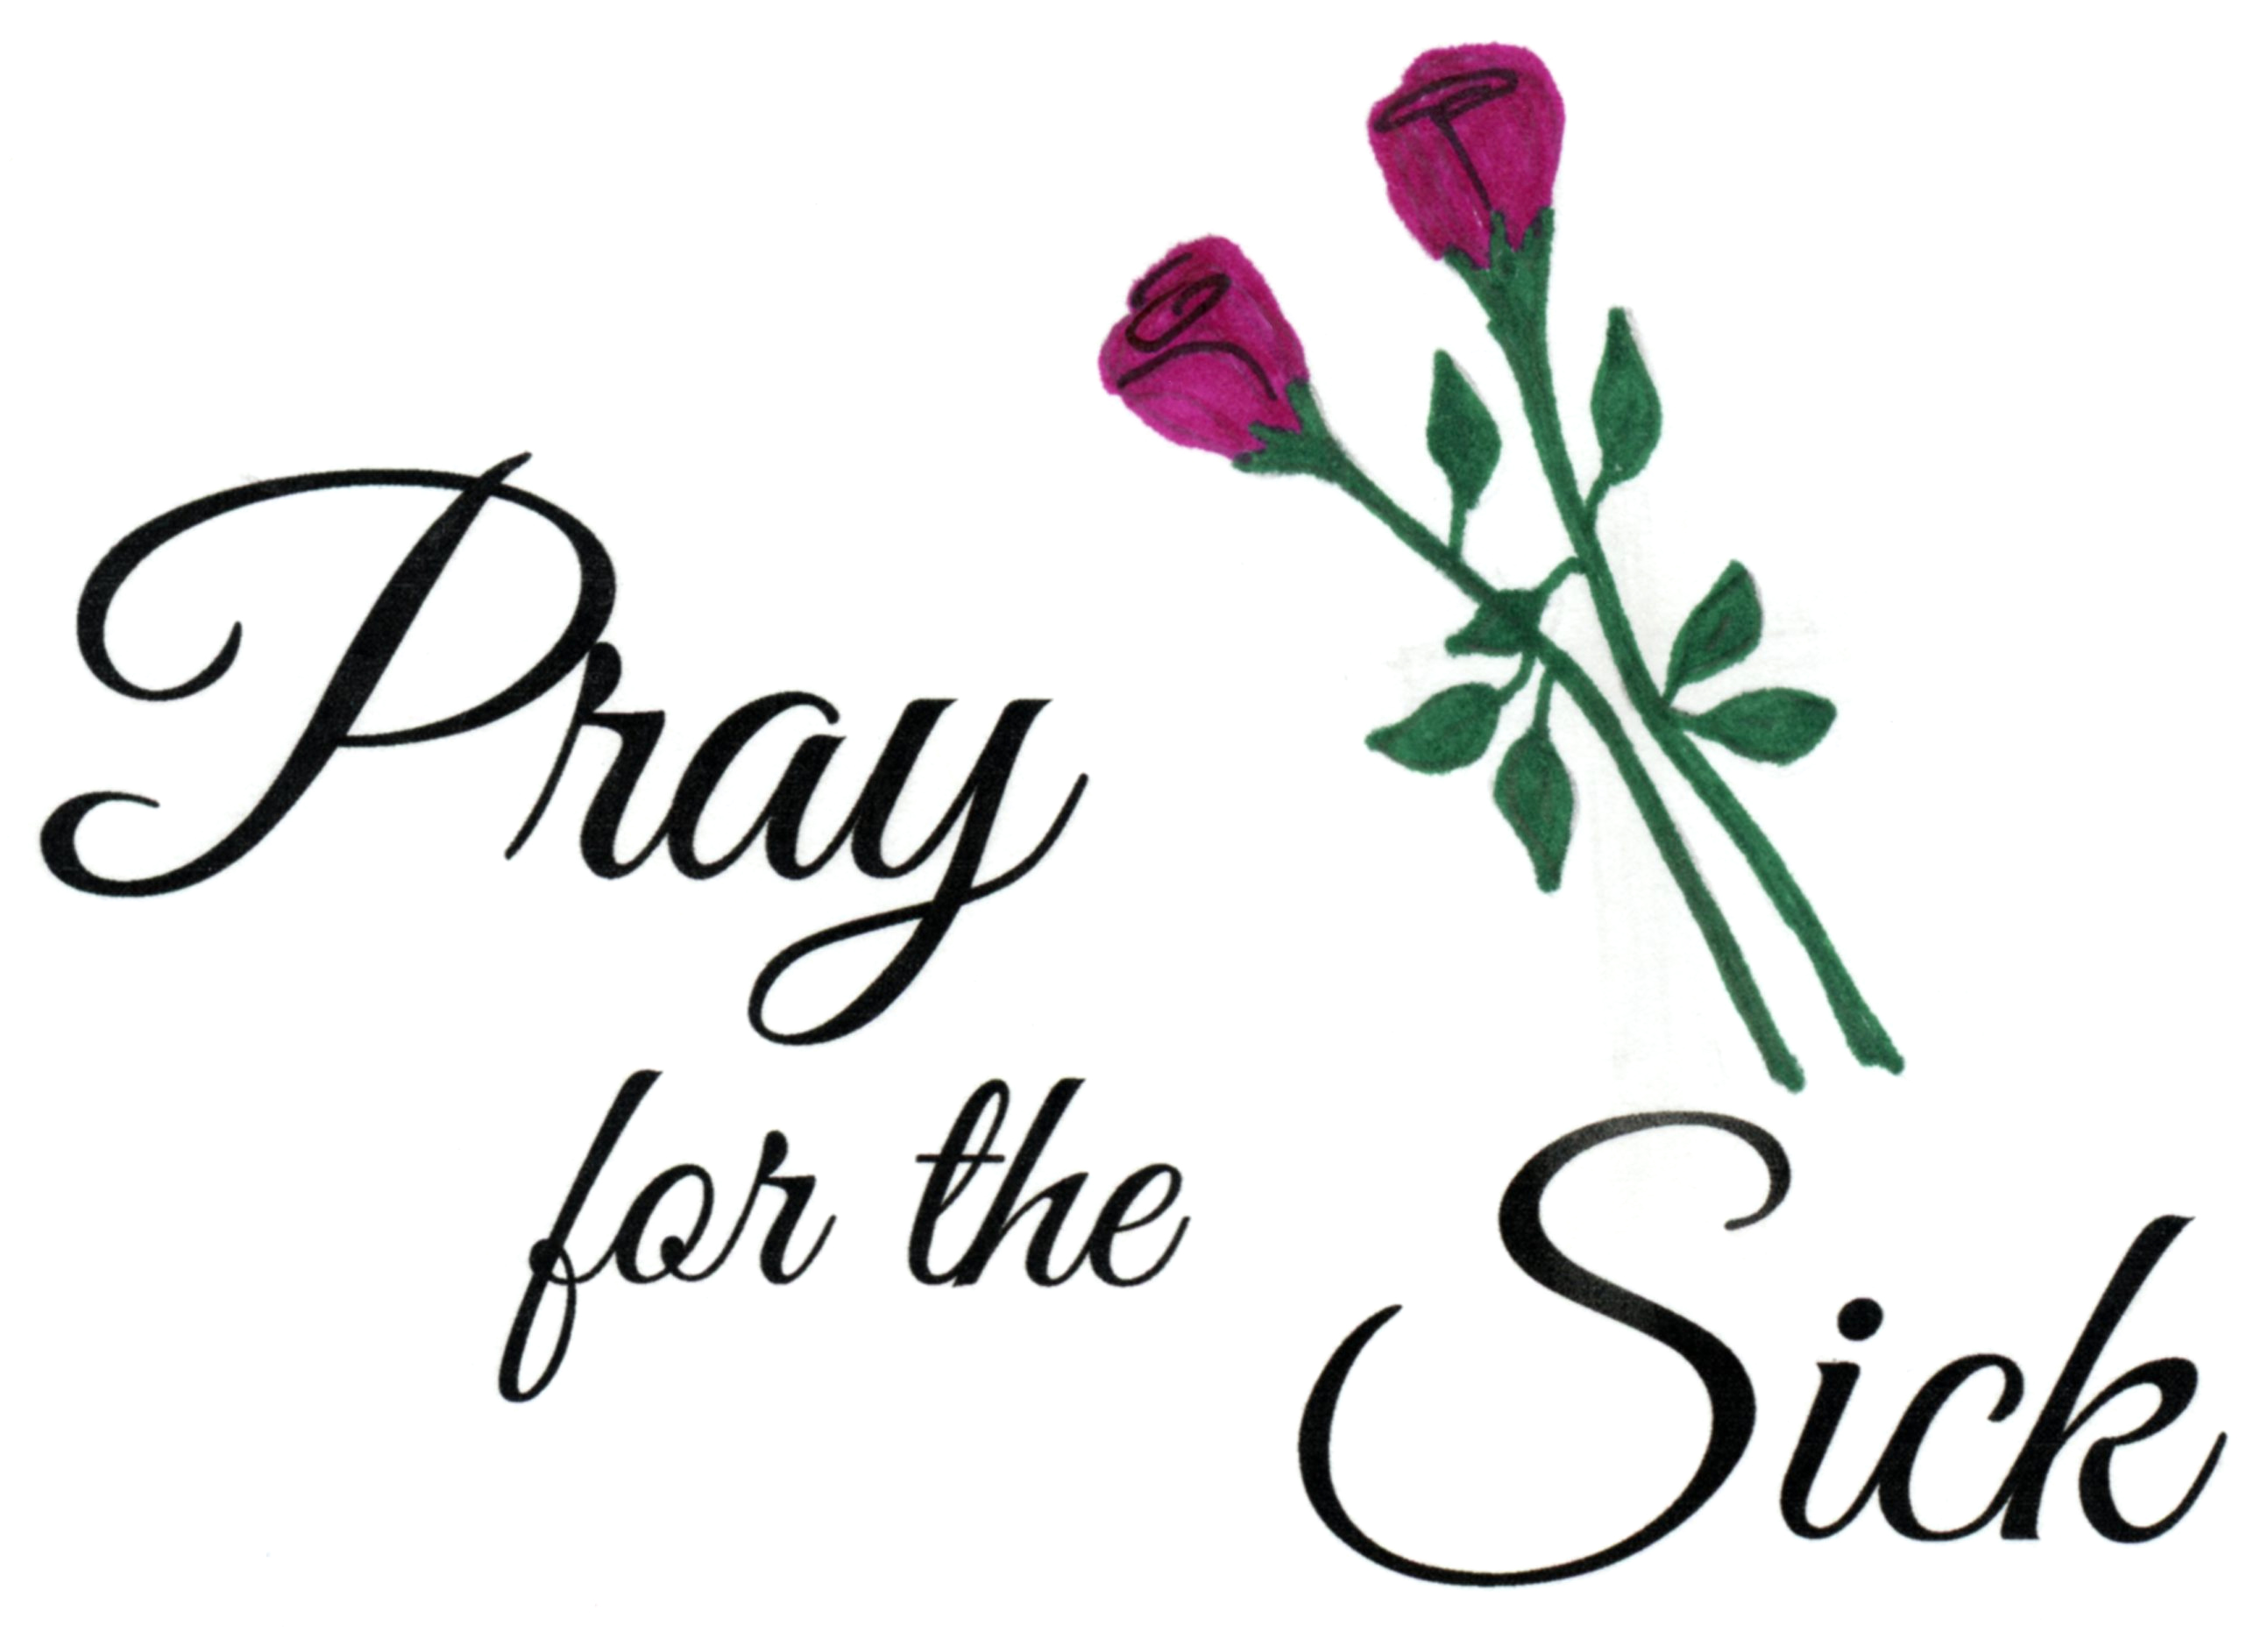
Parishioners who are sick and in need
of prayers can be added to our prayer
list by calling the Parish Office at
570-842-4995. Please pray for:
Carmen Nordstrom, Susan Golombos,
Joseph Falchek, Jeanne Tierney,
Pete Tambasco, Arline Chumacas, Jenny Filingo, Jerry White,
Jennifer Simis, Alan Lemech, Vincent Orazi, Ben Topar,
Craig Bozzacco, Bob Jantz, Donald Migliorato, Werner Henes,
Phyllis Braun, Richard Major, Vonette Castelblanco, Bill Vockroth, Jane Colwell, Jeanne Kopyta, Muriel Calame, Jamie Jantz,
Jason Scott Taylor, Donna Lewis, Joanne Arredondo, Vincent Natoli and all the sick of the Parish.

PRAYERS ANSWERED
I want to thank all who prayed for my recovery, especially my church family and Judy my faithful wife.
“A faithful friend is a sturdy shelter, he who finds one finds a treasure . . . SIRACH 6:14-19”
Your prayers, cards, letters, calls and visits were very much appreciated. MAY GOD BLESS YOU ALL. Bill Vockroth


STEWARDSHIP OF TALENT:
Feb. 11, 2018 SIXTH SUNDAY IN ORDINARY TIME
LECTORS:
Feb. 10th 4:00pm Kealy Ford
Feb. 11th 8:30am Susan Pilosi
9:45am Trevor Ophoff/Zach Jantzi
EXTRAORDINARY MINISTERS OF THE EUCHARIST:
Feb. 10th 4:00pm R. Natoli/L. Van Houtte
Feb. 11th 8:30am T. Butel/M. Chiodo
9:45am T. Butel/K. Fossetta
ALTAR SERVERS:
Feb. 10th 4:00pm Alan Hynes
Feb. 11th 8:30am Amanda Proch
9:45am Sharon Lenzer/Ayden Hull
HOSPITALITY & USHERS:
Feb. 10th 4:00pm Andrew Kelemen/Victor Benfatti
Feb. 11th 8:30am Richard Colwell/Tom Volpe
9:45am Frank Kopyta/Tom Quinn
Feb. 18, 2018 FIRST SUNDAY OF LENT
LECTORS:
Feb. 17th 4:00pm Lyne Van Houtte
Feb. 18th 8:30am Richard Colwell
9:45am Sharon Lenzer
EXTRAORDINARY MINISTERS OF THE EUCHARIST:
Feb. 17th 4:00pm T. Butel/R. Natoli
Feb. 18th 8:30am P. Manago/S. Pilosi
9:45am D. Killian/M. Croak
ALTAR SERVERS:
Feb. 17th 4:00pm Alan Hynes
Feb. 18th 8:30am Veronica Yanulavich
9:45am Amanda Proch
HOSPITALITY & USHERS:
Feb. 17th 4:00pm Andrew Kelemen/Victor Benfatti
Feb. 18th 8:30am Ed Snyder/Evan Sennefelder
9:45am Frank Kopyta/Richard Erazamus

Our Pilgrim Statue of the Blessed Virgin Mary

If she has not yet visited your home and you would like information or to sign up to have the Statue visit your home, please call Pat Manago at 570-848-2284.
This is where the statue will be traveling in the
weeks to come: 2/11-McCauley Family 2/18-McCauley Family 2/25-McCauley Family 3/04-Proch Family
3/11-OPEN 3/18-OPEN

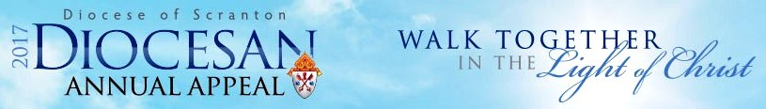
PLEASE REMEMBER TO SEND IN YOUR PLEDGE PAYMENTS!!
THANK YOU TO ALL WHO PLEDGED
WE HAVE SURPASSED OUR GOAL!
GOAL: $15,000.00
PLEDGED: $15,241.00
THANK YOU!!!!
OPERATION SNOWFLAKE

Communion Services will be cancelled any time North Pocono School District is delayed or cancelled. Weather delays and cancellations are broadcast on TV channels: WNEP 16 – WYOU 22 – WBRE 28.


ASH WEDNESDAY—FEBRUARY 14, 2018
Ashes will be distributed during each liturgy
Mass 8:30 AM
Communion Service 7:00 PM

ALL FRIDAYS DURING LENT—
MEAGER MEAL-SOUP AND BREAD FOLLOWED BY STATIONS OF THE CROSS AND A COMMUNION SERVICE

CONFESSIONS DURING LENT
Every Saturday from 3:15-3:45 PM

STEWARDSHIP OF TREASURE:


2/04/18
ENVELOPES (68): $ 1436.00
LOOSE: $ 208.00
FUEL (44): $ 276.00
FREE WILL OFFERING: $ 82.00

TOTAL: $ 2002.00

DIOCESAN COLLECTION:
CAMPAIGN FOR HUMAN DEVELOPMENT (2): $8.00
CARE & EDUCATION OF PRIESTS (25): $144.00

02/04 01/28 01/21 01/14
PEOPLE ATTENDING: 4:00PM 62 62 48 38
8:30AM 47 44 44 48
9:45AM 74 62 59 67

THANK YOU FOR YOUR GENEROSITY!


PASTORAL COUNCIL MEETING
MON. FEB. 12, 6:30PM
IN THE RECTORY.


THE SANDS CASINO
BETHLEHEM, PA
The Parish Finance counsel is sponsoring a bus trip to the Sands Casino in Bethlehem on Wednesday, March 7. Bus will leave Gouldsboro at 10:00am and return at 5:00pm. Cost: $25.00 per person
Rebates: $20.00 in slot play and $5.00 food.
To register please call Mary at 570-676-3711 or the Parish Office at 570-842-4995.



UPCOMING CLASSES
February 4, 11, 25
Feb 11-7th & 8th Grade Parent’s Meeting and Children’s Mass
COLLECTION FOR THE HOMELESS
The Faith Formation Classes are collecting items for the Homeless. We are looking for the following items:
- Band-Aids 6. Kleenex
- First aid cream 7. Chapstick
- Wet wipes 8. Socks
- Alcohol wipes 9. Cough Drops
- Handwarmers 10. Comb

Recipients of these items will be those at
the Homeless Day Program
"Street to Feet Day Center” in Stroudsburg, PA.
THANK YOU FOR YOUR CARING AND GIVING
TO HELP THE HOMELESS!!

DO YOU WANT TO KNOW MORE ABOUT THE ANNULMENT PROCESS?
In the Diocese of Scranton, the annulment process is now more “user-friendly” than you might expect, and there is no longer a processing fee. Please contact your parish life coordinator or the Diocesan Tribunal Office (570-207-2246) to begin a conversation. It is possible to get clear answers to these questions and to renew your connection with the Church.

